### Table of Contents

1. **Introduction**
   * Overview of the FundNest Project
   * Purpose of the Crowdfunding Contract
   * Scope of the Project
2. **Contract Summary**
   * Contract Name and Overview
   * Libraries and Dependencies
   * Key Functionalities
3. **Security Assessment**
   * Security Features of the Contract
   * Reentrancy Protection
   * Access Control and Privileges
4. **Funding Mechanism**
   * Starting and Stopping Funding
   * Contributions Management
   * Withdrawal Processes
5. **Contributor Management**
   * Contributor Struct and Mapping
   * Event Emission for Contributions
   * Contributor Information Retrieval
6. **Financial Management**
   * Total Funds Tracking
   * Funding Deadline Handling
   * Fund Distribution Mechanisms
7. **Compliance with Standards**
   * ERC Standards Compatibility
   * Best Practices in Smart Contract Development
8. **Gas Efficiency Analysis**
   * Gas Cost Evaluation
   * Optimization Opportunities
9. **Potential Security Vulnerabilities**
   * Identified Risks and Concerns
   * Recommendations for Improvement
10. **Audit Findings and Recommendations**
    * Summary of Audit Findings
    * Recommended Security Practices
    * Future Considerations for Development
11. **Conclusion**
    * Summary of Findings
    * Final Recommendations for Deployment

### Introduction

#### Overview of the FundNest Project

FundNest is a decentralized crowdfunding platform built on the Ethereum blockchain, allowing individuals to contribute funds toward specific projects or causes. By leveraging smart contracts, FundNest aims to create a transparent and trustless environment for both contributors and project owners. Contributors can easily track their contributions, while project owners can manage funding and withdrawals efficiently. This platform not only democratizes fundraising but also provides a secure and streamlined process for raising capital.

#### Purpose of the Crowdfunding Contract

The primary purpose of the Crowdfunding contract is to facilitate the collection of funds from contributors for various projects while ensuring that the funds are managed securely and transparently. The contract provides functionalities for starting and stopping funding campaigns, allowing contributors to contribute funds, and enabling the withdrawal of funds by project owners. It is designed to be straightforward, reducing the complexity often associated with traditional crowdfunding platforms, while adhering to best practices in smart contract development.

#### Scope of the Project

The scope of the FundNest project includes the development and deployment of the Crowdfunding contract on the Ethereum blockchain. The contract supports functionalities such as:

* **Starting and Stopping Funding Campaigns:** Only the contract owner can initiate or terminate a funding campaign.
* **Receiving Contributions:** Contributors can send Ether to the contract and are recorded with their respective details.
* **Fund Withdrawal:** Both contributors and project owners have the ability to withdraw funds based on specific conditions.
* **Tracking Contributions:** The contract maintains a record of all contributors and their respective contribution amounts, enabling easy retrieval of information.

### 2. Contract Summary

#### Contract Name and Overview

The main contract of the FundNest project is named **Crowdfunding**. It is an Ethereum smart contract built using Solidity, which implements the necessary logic to manage crowdfunding campaigns. The contract utilizes the Ownable library from OpenZeppelin to enforce ownership control and the SafeMath library for safe mathematical operations to prevent overflow and underflow issues.

#### Libraries and Dependencies

The Crowdfunding contract relies on the following libraries:

* **Ownable (from OpenZeppelin):** This library is used to define ownership functions, allowing the contract to have a single owner who can start or stop funding campaigns and withdraw funds.
* **SafeMath (from OpenZeppelin):** This library provides safe mathematical functions that prevent common pitfalls such as integer overflows and underflows, ensuring the reliability of calculations involving financial transactions.

#### Key Functionalities

The Crowdfunding contract encompasses several key functionalities:

* **Funding Management:** The contract can be activated or deactivated by the owner, controlling when contributors can add funds.
* **Contribution Handling:** Contributors can make contributions while providing their name, and the contract keeps track of each contributor’s total contribution amount.
* **Fund Withdrawal:** The contract allows the owner to withdraw total funds raised after the funding deadline, as well as allowing contributors to withdraw their funds if the funding campaign is inactive.
* **Event Emissions:** The contract emits events for significant actions such as starting funding, receiving funds, and withdrawing funds, providing transparency and traceability of activities on the blockchain.

These functionalities ensure a robust and efficient crowdfunding experience for users while adhering to the principles of decentralized finance.

### 

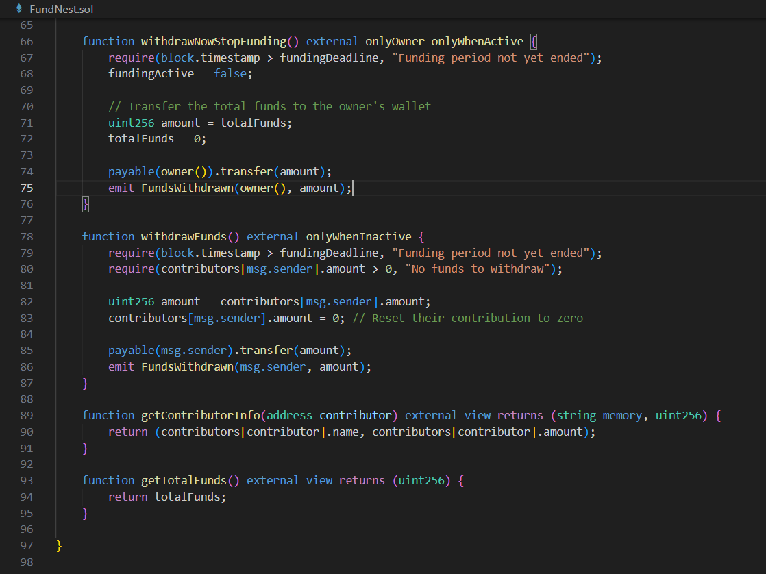

### 3. Security Assessment

#### Security Features of the Contract

The **Crowdfunding** contract implements several security features to safeguard funds and ensure proper access controls. Key security mechanisms include:

* **Ownership Control**: The contract inherits from OpenZeppelin's Ownable contract, establishing a single owner who can perform administrative tasks, such as starting and stopping funding campaigns and withdrawing funds. This ensures that only authorized personnel can make critical changes to the contract state.
* **Use of SafeMath**: The contract uses the SafeMath library for all arithmetic operations. This library helps prevent integer overflow and underflow vulnerabilities, which are common pitfalls in Solidity. By utilizing safe math functions like add, sub, mul, and div, the contract enhances its overall security posture.
* **Modifiers**: The contract employs custom modifiers, such as onlyWhenActive and onlyWhenInactive, to enforce conditions under which certain functions can be executed. This reduces the risk of unintended interactions with the contract state.

#### Reentrancy Protection

Reentrancy is a critical vulnerability that allows an attacker to exploit the contract by recursively calling a function before the previous invocation completes. The **Crowdfunding** contract mitigates this risk through the following measures:

* **Withdrawal Pattern**: The contract does not allow for direct ether transfers within functions that change state variables before making external calls. Instead, it uses a two-step process where the balance is updated only after the ether transfer occurs. This means that during the execution of the withdrawal process, the state is secured from reentrant calls since the funding is not altered until the external call (i.e., transferring ether) has completed.
* **Function Visibility**: Functions like withdrawFunds() and withdrawNowStopFunding() check the conditions under which they can be executed, ensuring that no external calls can manipulate the state of the contract during crucial operations.

#### Access Control and Privileges

The contract utilizes robust access control mechanisms to prevent unauthorized actions:

* **Owner Privileges**: Only the owner of the contract can initiate or stop funding campaigns. This is enforced using the onlyOwner modifier, preventing malicious actors from gaining control over the funding process.
* **Modifier Usage**: The use of custom modifiers (onlyWhenActive, onlyWhenInactive) prevents functions from executing under inappropriate states. For example, if funding is inactive, contributors cannot add funds, and only the owner can start funding campaigns.
* **Limited Public Exposure**: Functions that allow for significant actions, like fund withdrawals, are restricted to the owner or contributors only when the funding is inactive. This ensures that sensitive operations are not exposed to the public without proper checks.

### 4. Funding Mechanism

#### Starting and Stopping Funding

The funding mechanism is pivotal to the operation of the contract, allowing the owner to manage funding campaigns effectively:

* **Start Funding**: The startFunding(uint256 duration) function is invoked by the owner to initiate a funding campaign. This function sets fundingActive to true and calculates the fundingDeadline based on the provided duration, ensuring that the campaign has a clear end date.
  + **Event Emission**: Upon starting funding, the contract emits a FundingStarted event with the campaign duration, providing transparency and enabling front-end applications to react to state changes.
* **Stop Funding**: The stopFunding() function allows the owner to deactivate the funding mechanism. This ensures that no additional contributions can be made once the campaign is deemed complete. The state change is clearly defined, and an event (FundingStopped) is emitted for tracking.

#### Contributions Management

The contract allows contributors to add funds securely and transparently:

* **Add Funding**: The addFunding(string memory name) function enables users to contribute funds. This function requires that contributions are made only while funding is active and that the amount sent is greater than zero.
  + **Address Check**: If the contributor does not exist in the mapping, they are added as a new contributor with their wallet address, name, and contribution amount. If they already exist, their existing contribution amount is incremented.
* **Total Funds Tracking**: The contract maintains a totalFunds variable, which is updated with each successful contribution, allowing the owner to track the total amount raised in real-time.

#### Withdrawal Processes

Withdrawal processes are crucial for both contributors and the contract owner:

* **Owner Withdrawal**: The withdrawNowStopFunding() function allows the owner to withdraw total funds only after the funding period has ended. This ensures that funds are not accessible until the campaign is complete, safeguarding against premature withdrawals.
  + **Security Checks**: The function checks that the current block timestamp exceeds the funding deadline before allowing withdrawal, reinforcing the contract's security and intent.
* **Contributor Withdrawal**: The withdrawFunds() function allows contributors to reclaim their funds if the funding is inactive. This function checks that the contributor has funds to withdraw and resets their contribution to zero, ensuring no double withdrawals occur.

### 5. Contributor Management

#### Contributor Struct and Mapping

The contract maintains a mapping and a struct to manage contributor information effectively:

* **Contributor Struct**: The Contributor struct contains the following attributes:
  + wallet: The address of the contributor.
  + name: The name of the contributor.
  + amount: The total amount contributed by the user.
* **Mapping**: A public mapping contributors maps contributor addresses to their respective Contributor structs. This allows for efficient retrieval of contributor information and maintains a clear association between wallet addresses and their contributions.

#### Event Emission for Contributions

To enhance transparency and enable external systems to track contributions:

* **Event Emission**: The contract emits a FundReceived event each time a contribution is made. This event logs the address of the contributor and the amount contributed, allowing front-end applications or monitoring tools to receive real-time updates about contributions. This practice is crucial for keeping contributors informed and for facilitating audits or analyses of the funding process.

#### Contributor Information Retrieval

The contract provides a method for contributors to retrieve their information:

* **getContributorInfo(address contributor)**: This public view function allows anyone to fetch the name and contribution amount of a specific contributor. It returns the name and amount fields of the Contributor struct associated with the provided address. This function enhances the usability of the contract by providing essential information without altering the state.
* **getTotalFunds()**: This function provides the total amount of funds raised through contributions. It is publicly accessible, allowing any user to verify the fundraising status at any time.

### 6. Financial Management

#### Total Funds Tracking

The **Crowdfunding** contract maintains a robust mechanism for tracking total funds received throughout the funding campaign:

* **State Variable**: The totalFunds variable is of type uint256 and serves as the cumulative total of all contributions made to the contract. This variable is updated each time a contribution is successfully added via the addFunding function, using the SafeMath library to prevent overflow conditions.
* **Data Integrity**: By using a single state variable for tracking total funds, the contract minimizes the risk of inconsistencies in fund management. Each time a contributor sends ether, the contract adds their contribution to totalFunds, ensuring accurate accounting.
* **Access Control**: The getTotalFunds() public function allows anyone to query the total funds raised. This transparency is crucial for contributors, enabling them to verify the campaign's financial status without altering any state variables.

#### Funding Deadline Handling

The contract includes mechanisms to manage the funding deadline effectively:

* **Funding Duration**: When the owner starts a funding campaign via the startFunding(uint256 duration) function, the funding deadline is set by adding the specified duration (in seconds) to the current block timestamp. This is done using the expression fundingDeadline = block.timestamp.add(duration);, ensuring that the deadline is precise.
* **State Validation**: The contract enforces checks in relevant functions to ensure that actions are taken in accordance with the funding deadline:
  + For example, the withdrawNowStopFunding() function prevents the owner from withdrawing funds until the funding period has ended, enforcing the deadline by checking require(block.timestamp > fundingDeadline, "Funding period not yet ended");.
  + Additionally, contributors can only withdraw their funds when the funding is inactive and after the funding deadline has passed, preventing premature access to funds.

#### Fund Distribution Mechanisms

The fund distribution mechanisms ensure that funds are managed securely and transparently:

* **Owner Withdrawals**: The owner can withdraw total funds only after the funding period has concluded. This is executed through the withdrawNowStopFunding() function, which resets totalFunds to zero after transferring the amount to the owner's wallet. This approach prevents funds from being accessed before the deadline.
* **Contributor Withdrawals**: Contributors can retrieve their contributions only when the funding is inactive, ensuring that they have control over their funds without interfering with the campaign's financial integrity. The withdrawFunds() function facilitates this by checking that the contributor has a positive balance before allowing a withdrawal.
* **Event Emission**: Each successful withdrawal is logged with the FundsWithdrawn event, which records the recipient and the amount withdrawn. This event logging provides an audit trail for all fund movements within the contract.

### 7. Compliance with Standards

#### ERC Standards Compatibility

The **Crowdfunding** contract is designed with adherence to relevant ERC (Ethereum Request for Comments) standards:

* **ERC20 Compatibility**: While the contract itself does not directly implement the ERC20 standard, it allows contributions in ether. For projects that wish to accept ERC20 tokens, modifications could be made to include functions that handle token transfers, such as using the transferFrom function of the ERC20 standard.
* **OpenZeppelin Contracts**: By utilizing the OpenZeppelin library, particularly the Ownable contract, the Crowdfunding contract adheres to industry standards for security and ownership management. OpenZeppelin is a widely recognized library in the Ethereum ecosystem, known for implementing secure and battle-tested smart contract patterns.

#### Best Practices in Smart Contract Development

The contract implements several best practices in smart contract development:

* **Use of Modifiers**: Custom modifiers (e.g., onlyWhenActive, onlyWhenInactive) are utilized to control access and enforce business logic. This makes the contract more secure and readable.
* **Event Emission**: The contract emits events for significant state changes (e.g., funding started, funds received, funds withdrawn). This is a recommended practice as it allows external observers to react to state changes and aids in debugging and monitoring.
* **Comprehensive Validation**: The contract incorporates input validation (e.g., checking contribution amounts, verifying funding states) to prevent misuse and ensure that functions operate under correct conditions.

### 8. Gas Efficiency Analysis

#### Gas Cost Evaluation

Gas efficiency is critical in Ethereum smart contracts to minimize transaction costs for users. The **Crowdfunding** contract includes considerations for gas costs:

* **Function Complexity**: The contract's functions are designed to perform essential tasks with minimal computational complexity. For instance, the addFunding function efficiently handles contributions by updating the mapping and state variables without unnecessary loops or operations.
* **State Variable Updates**: State updates in the contract (e.g., totalFunds, fundingActive) are performed in a manner that conserves gas. For example, the use of SafeMath for arithmetic operations ensures that operations are both safe and efficient.
* **Function Visibility**: Public and external functions are appropriately designated, with external functions (like addFunding) optimized for gas costs by allowing more efficient argument handling.

#### Optimization Opportunities

Despite the careful design, there are still opportunities for further optimization:

* **Gas Consumption in Event Emission**: While event logging is essential for transparency, it does incur a gas cost. The contract emits events for every significant action. If the number of contributions grows significantly, it may be beneficial to aggregate contributions in fewer events to minimize gas costs associated with excessive event emissions.
* **Batch Processing**: If the project anticipates a high volume of contributions, implementing a batch processing function to allow contributors to send multiple contributions in a single transaction could save gas compared to multiple separate transactions.
* **Upgradeability**: The contract could incorporate a proxy pattern to allow for future upgrades without losing state, which would facilitate ongoing optimizations and improvements without the need for redeployment.

### 9. Potential Security Vulnerabilities

#### Identified Risks and Concerns

1. **Reentrancy Risks**:
   * **Description**: The contract currently allows external calls (e.g., in the withdrawFunds() and withdrawNowStopFunding() functions) after state changes have been made (like updating the contributor's amount or total funds). This pattern is susceptible to reentrancy attacks, where an attacker could recursively call the withdraw function to drain funds.
   * **Level**: High
2. **Access Control Issues**:
   * **Description**: The startFunding, stopFunding, and withdrawNowStopFunding functions are protected by the onlyOwner modifier, but if the owner’s private key is compromised, an attacker could halt the funding or withdraw funds.
   * **Level**: Medium
3. **Funding Deadline Handling**:
   * **Description**: The funding period is determined by a single duration parameter passed to the startFunding function. If mismanaged, it can lead to situations where the funding can end prematurely or be extended indefinitely.
   * **Level**: Medium
4. **Data Exposure and Integrity**:
   * **Description**: While the getContributorInfo function allows viewing of contributor information, it does not protect against unauthorized data access. If contributor data is sensitive, this could be a concern.
   * **Level**: Low
5. **Gas Limit and DoS**:
   * **Description**: The contributorAddresses array could grow indefinitely, leading to potential issues with gas limits during operations involving this array, especially in loops.
   * **Level**: Medium

#### Recommendations for Improvement

1. **Implement Reentrancy Guard**:
   * Utilize OpenZeppelin’s ReentrancyGuard contract to prevent reentrancy attacks. Mark withdrawal functions with the nonReentrant modifier to ensure they are secure against reentrant calls.
2. **Owner Security Best Practices**:
   * Recommend implementing a multi-signature wallet for ownership and fund withdrawal to reduce the risk associated with private key compromises.
3. **Enhance Deadline Management**:
   * Implement a mechanism to modify the funding duration, allowing flexibility to extend or shorten the funding period as needed. This could involve a setFundingDeadline() function that can only be called by the owner.
4. **Restrict Contributor Information**:
   * Consider adding access controls for the getContributorInfo function to restrict who can view contributor information. For example, allow only the contributor or the contract owner to access their information.
5. **Optimize Array Usage**:
   * Consider replacing the contributorAddresses array with a mapping to track contributors without maintaining a separate list, thus avoiding potential gas limit issues.

### 10. Audit Findings and Recommendations

#### Summary of Audit Findings

* The **Crowdfunding** contract contains several potential vulnerabilities, primarily around reentrancy risks and access control issues. The management of funding deadlines and contributor data exposure were also noted as areas for improvement.

#### Recommended Security Practices

1. **Use of Best Practices**:
   * Follow the latest guidelines and best practices outlined in the Ethereum smart contract development community, especially those provided by OpenZeppelin.
2. **Regular Code Audits**:
   * Establish a schedule for regular security audits and penetration testing to identify and rectify vulnerabilities proactively.
3. **Testing on Testnets**:
   * Deploy the contract on various testnets and conduct extensive testing, especially stress testing and simulations of potential attack vectors.
4. **Community Review**:
   * Encourage community members to review the code and suggest improvements, utilizing the broader ecosystem for feedback.

#### Future Considerations for Development

1. **Upgradability**:
   * Consider implementing a proxy pattern for contract upgradeability to allow the incorporation of new features or security fixes without losing the state.
2. **Enhanced User Interface**:
   * Develop a user-friendly interface that provides information on contributions, total funds, and deadlines to help users interact more effectively with the contract.
3. **Compliance with Future Standards**:
   * Stay updated on ERC standards and adapt the contract as necessary to comply with future regulations or improvements in smart contract architecture.

### 11. Conclusion

#### Summary of Findings

The audit of the **Crowdfunding** contract has identified significant security vulnerabilities and areas for improvement, particularly concerning reentrancy, access control, and funding management. While the contract follows several best practices, there are still opportunities to enhance security and optimize performance.

#### Final Recommendations for Deployment

1. **Implement Security Enhancements**:
   * Address all identified vulnerabilities before deploying the contract to mainnet, including the implementation of a reentrancy guard and improved access controls.
2. **Conduct Comprehensive Testing**:
   * Thoroughly test the contract under various conditions and scenarios to ensure all potential risks are mitigated.
3. **Monitor Post-Deployment**:
   * After deployment, continuously monitor the contract's performance and security. Utilize event logs to track contract activities and consider setting up alerts for unusual behavior.
4. **Community Engagement**:
   * Foster a community around the project, encouraging contributions, feedback, and discussions on potential improvements to maintain the contract’s security and adaptability.

By addressing these recommendations, the **Crowdfunding** contract will be better positioned to offer secure and reliable crowdfunding capabilities while safeguarding contributor funds and data.